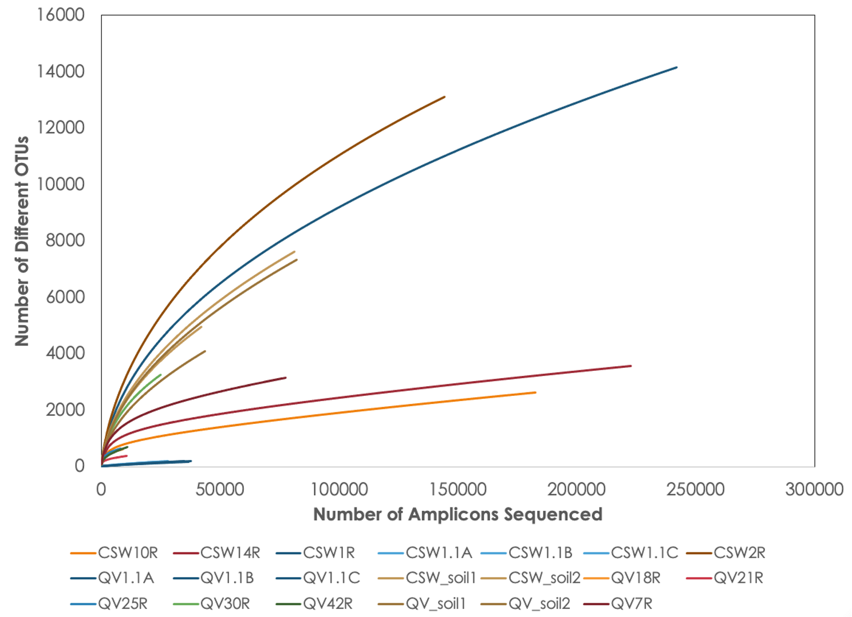
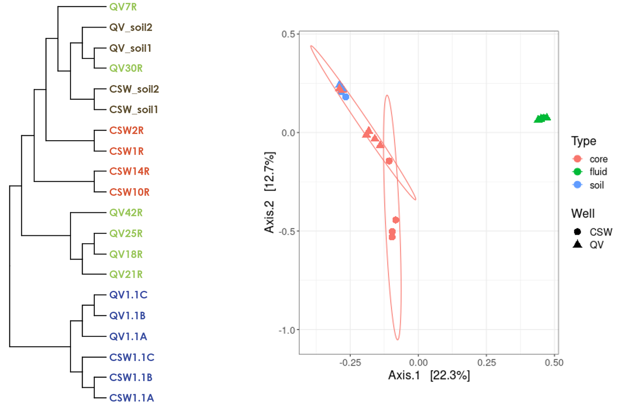

Figure S1 - Alpha- and beta-diversity measures of bacterial dataset.
(A) Rarefaction analysis of bacterial 16S rRNA gene amplicon sequences. (B) Community similarity dendrogram calculated from Sørenson diversity index. (C) MDS plot of bacterial community similarity calculated from the Bray-Curtis diversity index.

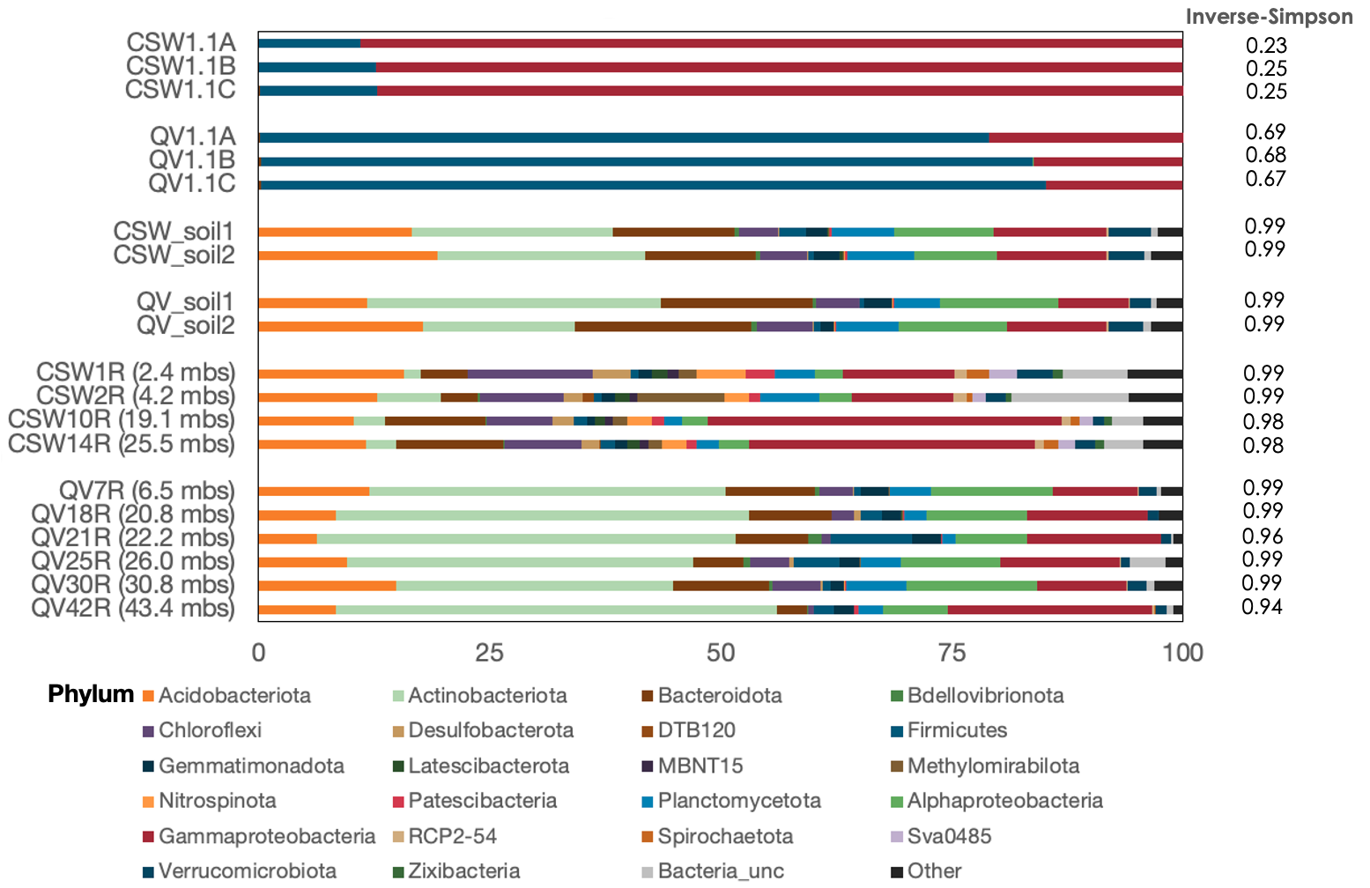Figure S2 - Relative abundance of bacteria in the fluid, soil, and core samples at the Phylum level.
Due to its disproportionate abundance, the phylum Proteobacteria is represented at the Class level with Alphaproteobacteria and Gammaproteobacteria. No other classes of the Proteobacteria were detected. ‘Other’ represents phyla which were not more than 1% relative abundance of a single sample. Depths of core samples are included in parentheses beside the sample name.

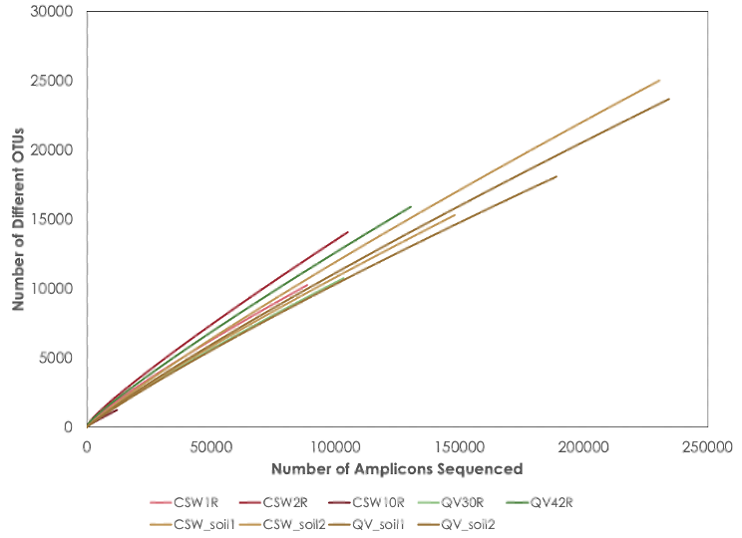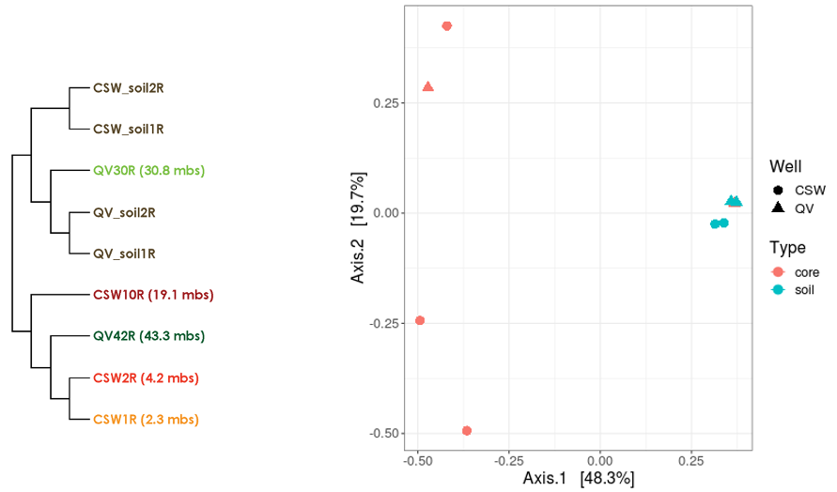Figure S3 - Alpha- and beta-diversity measures of archaeal dataset.
(A) Rarefaction analysis of archaeal 16S rRNA amplicon sequences. (B) Community similarity dendrogram calculated from Sørenson diversity index. (C) MDS plot of archaeal community similarity calculated from the Bray-Curtis diversity index.

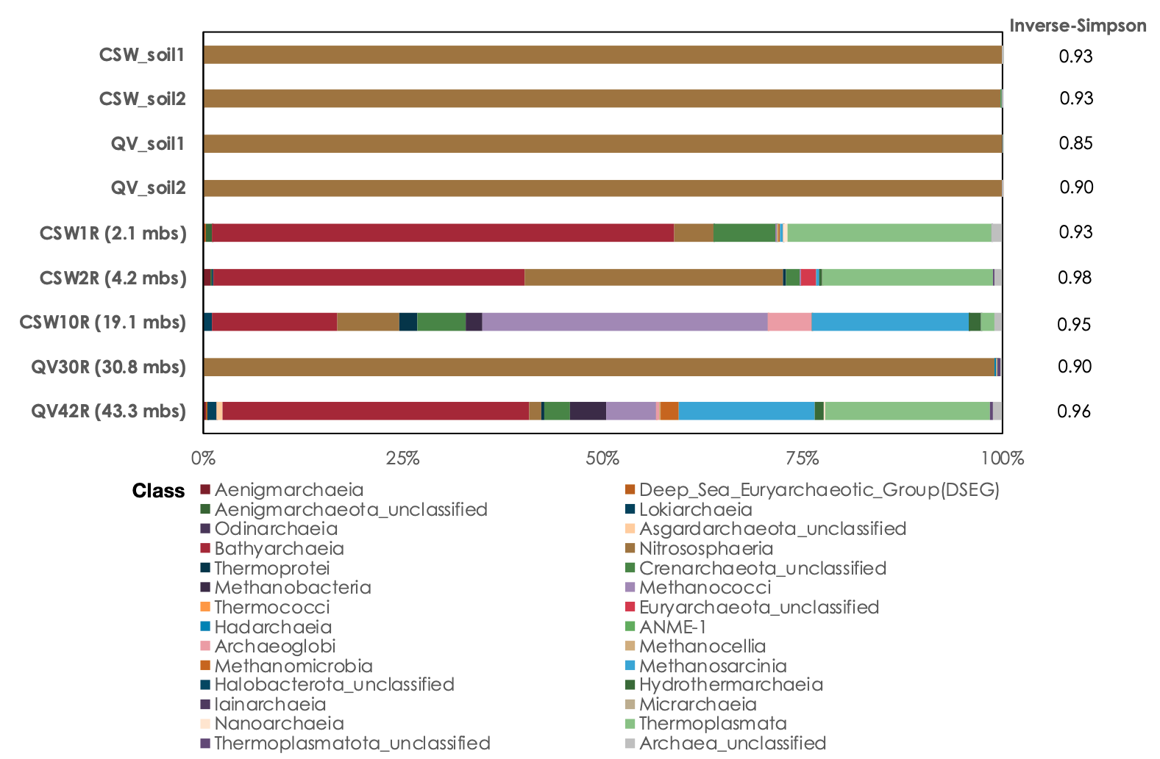

Figure S4 - Relative abundance of archaea at the Class level. Depths of core samples are included in parentheses beside the sample name.

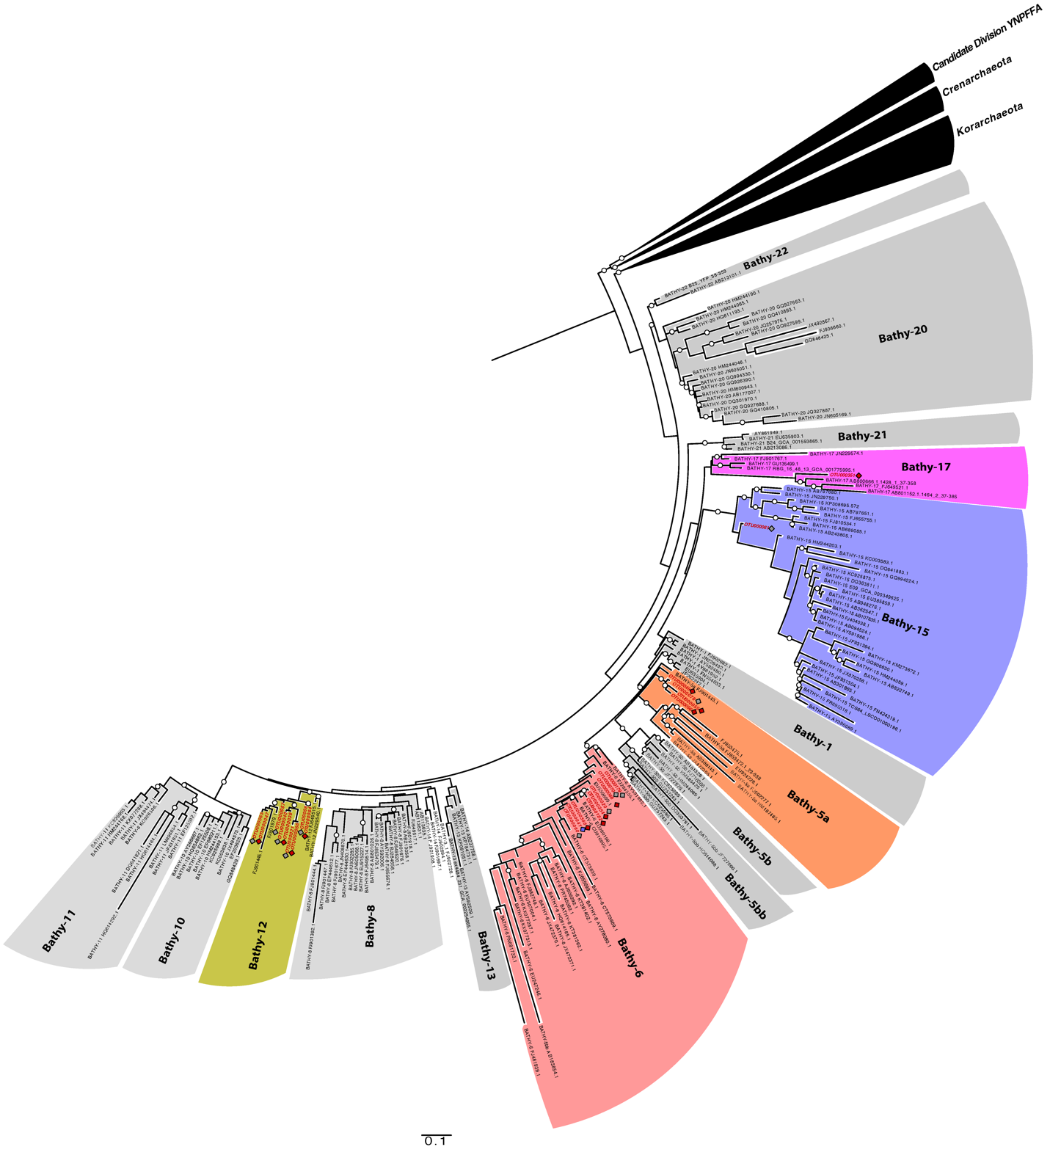Figure S5 - 16S rRNA phylogenetic tree of Bathyarchaeota OTUs. OTUs from this study are highlighted in red and represented in non-gray Bathyarchaeota subgroups. Based on concatenated alignment of 16S rRNA gene V4-V6 hypervariable regions of representative sequences from this study and Zhou et al. 2018. Crenarchaeota, Korarchaeota, and Candidatus YNPFFA sequences are referenced as outgroups. Bootstrap values > 0.7 are shown with white dots. Core-enriched OTUs exclusive to CSW and QV30 cores are indicated by red and blue diamonds, respectively. OTUs marked by gray diamonds are found both in cores.
References
Zhou Z, Pan J, Wang F, Gu JD, Li M. Bathyarchaeota: globally distributed metabolic generalists in anoxic environments. FEMS Microbiology Reviews. 2018 Sep 1;42(5):639–55.

